Name: Qurat-ul-ain
Task: Task report day 3
Date: 24 September 2026

Topics:
Main topics of today learning is Links,Images,List& Page Navigaton.
Today I learn:
- Learn about absolute and relative links.
- How to use anchor tags.
- How to create same page navigation using id.
- How to add images using image tag <img> and importance of alt tag.
- How to create a ordered or unordered list.
- How to add external links.

Task No:03
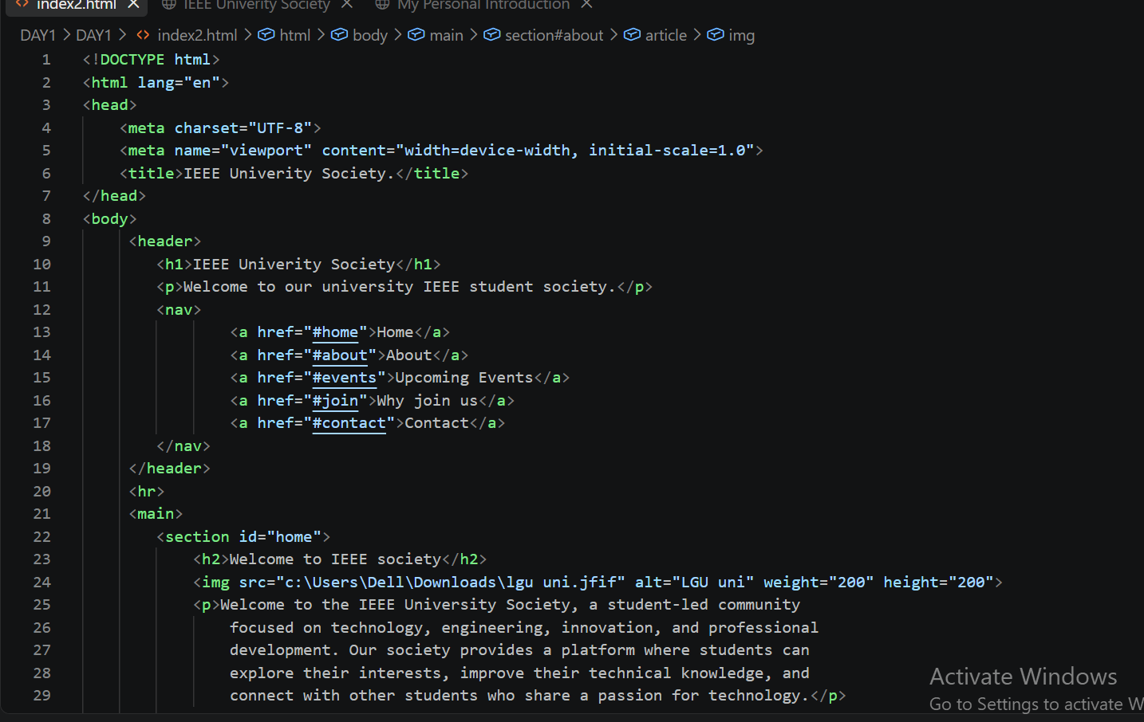
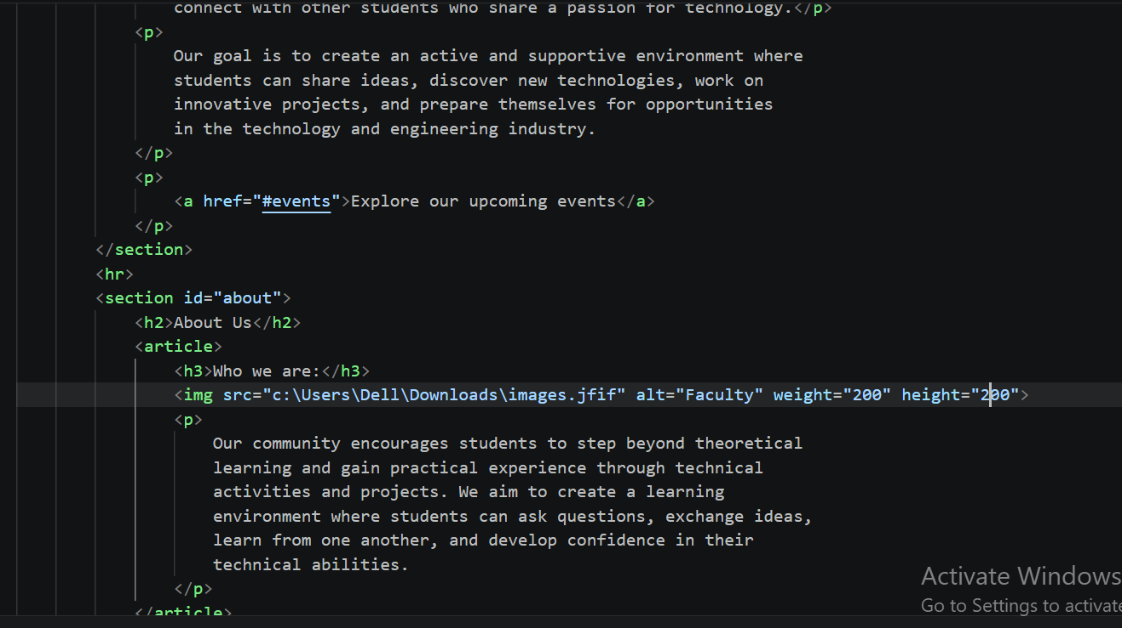
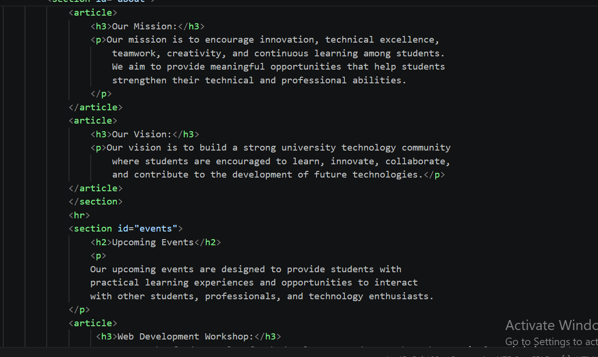
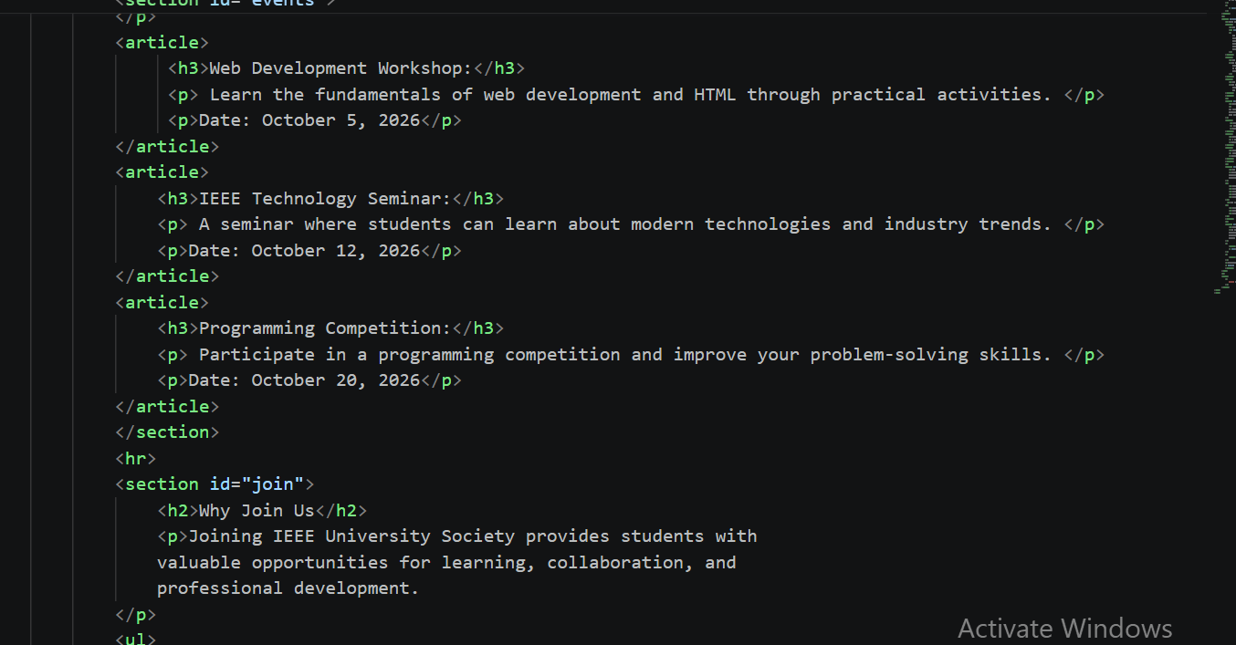
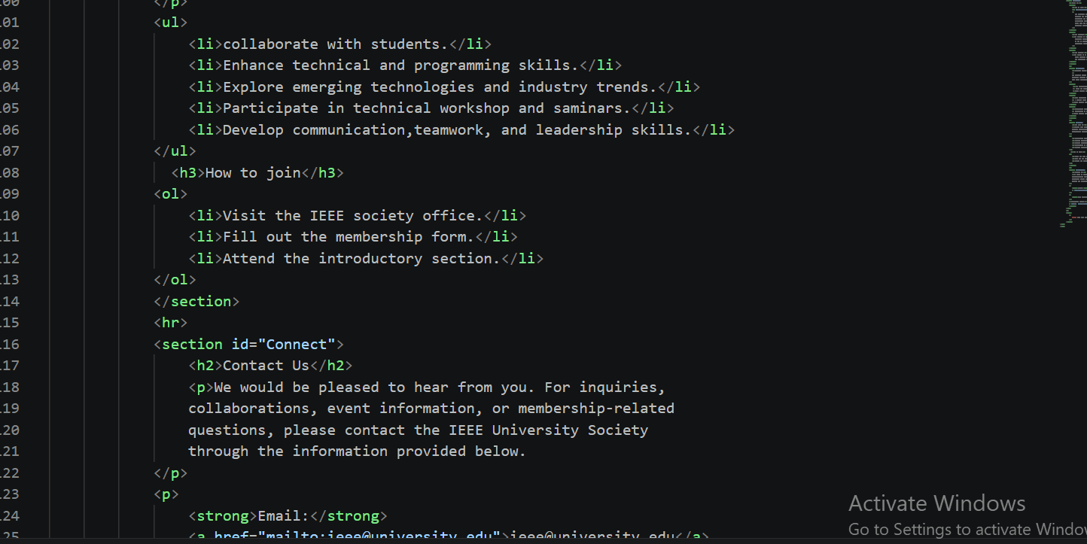
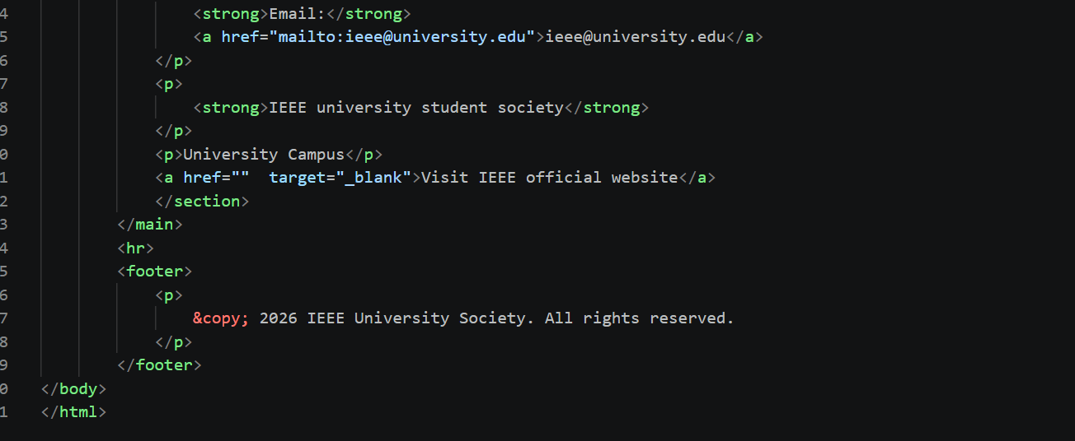

RESULT:
